Regional Profiles of the Pacific Northwest

Region: _______________________________________

Group members: _______________________________________________________________________________________

Description
So far this unit, we have been introduced to the cultural, physical and geological diversity of the Pacific Northwest. It’s also important to realize the difficulty in categorizing what comprises the borders of the Northwest due to the diversity within the region itself. In this regional profiles project, you will delved into one specific area/region of the Pacific Northwest that is tied together that make-up its natural environment.

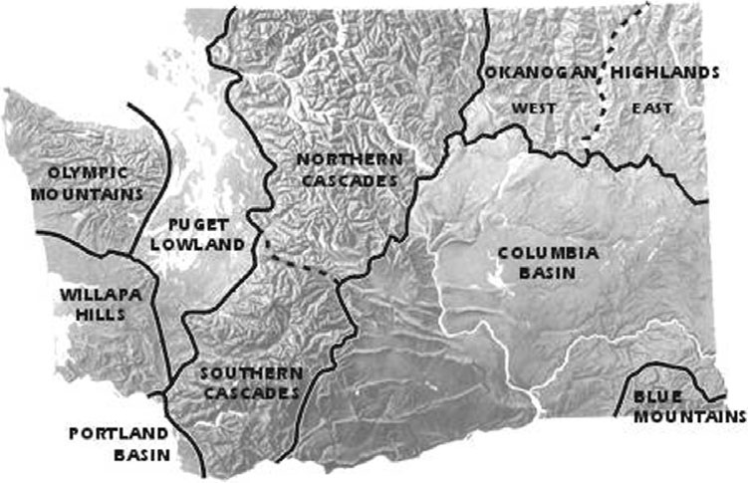
Task
- You will be divided into groups to research a specific region of the Pacific Northwest.
- As a group, you will identify the following aspects of your region: location/boundaries, climate, physical features, soils/vegetation, population, agriculture, industry, natural resources, transportation, recreation, tourist attractions, demographics, current events, major cities & towns, and current events.
- As a group create a power-point type presentation about your region in the form of a “virtual road trip” to educate the rest of the class.
- Your presentation should include your research, as you navigate us through several “key” locations that emphasis the uniqueness of your region’s natural environment.

Virtual road trip considerations
- What time of the year? Different characteristics for different seasons?
- Where will you start/finish – who will take the lead on which portions…
- What do you see ecologically – trees, plants, etc.
- What attractions are you interested in seeing, and what did you learn while you were there?
- What did you avoid, or what will you exclude the next time - why?
- Recreational activities…
- Major cities, towns…
- Would you go back, would you recommend the trip, why?
- What will be your soundtrack and playlist (at least 5 songs)
- What are your road trip snacks? Pick at least 5 and bring at least 1 to share!

Timeline
Day 1 Monday , February 10th
  - Use the time today to divide up the research in your group.
  - Rubric Review
Classwork/Homework: Develop 1-2 pages of notes pertaining to your region/section.
Day 2 Tuesday, February 11th
  - Research in Library
  - Narrow down your information and research to specific aspects you wish to include in your “road trip” power-point.
  - Classwork: collaborate with group on presentation, finishing touches
  - Homework self-directed
  - Before Class Thursday - Presentation due via email: ullandr@issaquah.wednet.edu
Day 3 Thursday February 13th.
- 5 min to gather with group for final preparations.
- Presentations
- Goal is to complete all presentations.

Resources: We will be using computers to do most of the research. Your textbooks are full of solid information as well specific details, but are limited. It will provide some of the information you will need, but you should spice it up with extra information you find through internet research.

Grading: Although this is a group project, you will be graded as an individual. Grading will consist of three (3) parts: The group process, the product itself, and the presentation. A scoring rubric will be used for the final assessment which will represent the aspects listed on the grading criteria.

Content of Presentation*-
- The group PowerPoint consists of detailed information on the following:
  - Map and basic definition of the physical & cultural boundaries of your region
  - Information on the climate of your region and how that impacts other aspects of your region (agriculture, industry, etc).
  - Important physical features of your region (notable geologic features, mountains, rivers, etc.) and how they impact life in the region (tourism, agriculture, etc.)
  - Soils & significance of soil type (in terms of agriculture, industry, etc).
  - Vegetation information & significance (in terms of industry, tourism, etc).
  - Agriculture (How central is agriculture to the region? What are the main crops grown in the region and why? What is the source of irrigation? etc.)
  - Industry (What are the main industries in the region - historically and present day? Why and how does this connect to natural resources, soils, vegetation, etc.?)
  - Natural resources (What natural resources exist in this region? How have these been influenced by geologic history & soil, vegetation, etc.? How have these impacted industry?)
  - Economy (what does the economy of the region look like, generally? It is more or less wealthy than other regions of the NW? Does it differ by county within the region? Is this a diversified economy of is it dependent on one industry?)
  - Transportation (specific major highways, railways, etc. that run through the region, information on how these transformed the region, and why they are significant - think connection to industry, agriculture, tourism, etc.)
  - Recreation (What seems to be the main types of recreation in your region? How does the landscape, climate, and physical features impact this?)
  - Tourist attractions (How big is the tourist industry in your region? What are the main attractions - physical, cultural, etc.?)
  - Recent population and demographic information (How populated is your region compared to the other regions of the NW? What is the racial makeup of your region? Is it diverse? Is it homogenous? Are there Native American reservations in your region?)
  - Major cities & towns (What are the urban centers of your region? How and why are they important?)
  - Entertainment - playlist and road trip snacks
  - Works Cited (MLA format)
Grading Criteria
Criteria 1: The Process
Those expecting an “A” on this assignment should meet the following criteria:
- All students are on task and working on the project during class time
- All students are kind and helpful to other group members
- Students are sharing responsibilities within the group so that one person is not stuck doing all of the work

Criteria 2: The Product
Those expecting an “A” on this assignment should meet the following criteria:
The slides should contain information based off of the necessary *Content of Presentation
- Presentation should contain a variety of visuals to help represent and better describe the region
- Each slide provides an explicit explanation as to how one particular section connects to the other aspects of the region
- The Presentation is emailed to Mr. Ulland (ullandr@issaquah.wednet.edu) on time for the presentation.

The Presentation
Those expecting an “A” on this assignment should meet the following criteria:
- The group is ready to go at their presentation time
- Each member of the group presents a part to the class and it is clear which slides they produced.
- Each group member uses a voice that is loud enough to understand anywhere in the room
- All visuals and bullet points in the PowerPoint are explained and elaborated on by the presenter

