Regional Profiles of the Pacific Northwest

Region: _______________________________________

Group members: _______________________________________________________________________________________

Description
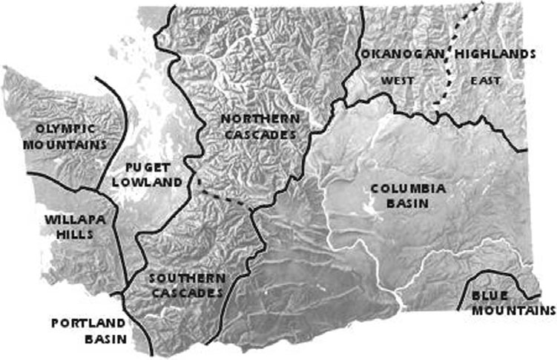
So far this unit, we have been introduced to the cultural, physical and geological diversity of the Pacific Northwest. It’s also important to realize the difficulty in categorizing what comprises the borders of the Northwest due to the diversity within the region itself. In this regional profiles project, you will delved into one specific area/region of the Pacific Northwest that is tied together that make-up its natural environment.
Task
- Pick a region of WA out of the following- Olympic Moutains, Willapa Hills, Cascades, Columbia Basin, Okanogan Highlands. .
- You will identify the following aspects of your region: location/boundaries, climate, physical features, population, industry, natural resources , recreation, tourist attractions, demographics, current events, major cities & towns, and current events.
- Create a power-point type presentation about your region in the form of a “virtual road trip” to educate the rest of the class.
- Your slides should include your research, as you navigate us through several “key” locations that emphasis the uniqueness of your region’s natural environment.

Virtual road trip considerations
- What time of the year? Different characteristics for different seasons?
- Where will you start/finish – who will take the lead on which portions…
- What do you see ecologically – trees, plants, etc.
- What attractions are you interested in seeing, and what did you learn while you were there?
- What did you avoid, or what will you exclude the next time - why?
- Major cities, towns & Recreational activities

Resources: You can use a computer to do most of the research. Your textbooks are also full of solid information as well specific details, but are limited. It will provide some of the information you will need, but you should spice it up with extra information you find through internet research.

Grading: Although this is a group project, you will be graded as an individual. Grading will consist of three (3) parts: The group process, the product itself, and the presentation. A scoring rubric will be used for the final assessment which will represent the aspects listed on the grading criteria.

Content of Presentation*-
- The PowerPoint consists of detailed information on the following:
  - Map and basic definition of the physical & cultural boundaries of your region
  - Information on the climate of your region and how that impacts other aspects of your region (agriculture, industry, etc).
  - Important physical features of your region (notable geologic features, mountains, rivers, etc.) and how they impact life in the region (tourism, agriculture, etc.)
  - Industry (What are the main industries in the region - historically and present day? Why and how does this connect to natural resources, soils, vegetation, etc.?)
  - Natural resources (What natural resources exist in this region? How have these been influenced by geologic history & soil, vegetation, etc.? How have these impacted industry?)
  - Recreation (What seems to be the main types of recreation in your region? How does the landscape, climate, and physical features impact this?)
  - Tourist attractions (How big is the tourist industry in your region? What are the main attractions - physical, cultural, etc.?)
  - Recent population and demographic information (How populated is your region compared to the other regions of the NW? What is the racial makeup of your region? Is it diverse? Is it homogenous? Are there Native American reservations in your region?)
  - Major cities & towns (What are the urban centers of your region? How and why are they important?)
  - Works Cited (MLA format)
Grading Criteria
The Product
Those expecting an “A” on this assignment should meet the following criteria:
The slides should contain information based off of the necessary *Content of Presentation
- Presentation should contain a variety of visuals to help represent and better describe the region
- Each slide provides an explicit explanation as to how one particular section connects to the other aspects of the region
- The Presentation is emailed to Mr. Ulland (ullandr@issaquah.wednet.edu) on time for the presentation.

