The History of the Caste System
By USHistory.org, adapted by Newsela staff
Ask a Hindu person to explain the nature of the caste system, a class structure that's determined by birth. He or she might start to tell the story of Brahma. This was a four-headed, four-handed god who was worshiped as the creator of the universe.
According to ancient texts, the division of Indian society was based on Brahma's explanation of four distinct groups.
Priests and teachers were cast from Brahma's mouth, rulers and warriors from his arms, merchants and traders from his thighs and workers and peasants from his feet.
Others might say India's caste system is based on biology or the notion that all living things inherit a particular set of qualities. Some inherit wisdom and intelligence, some get pride and passion and others are stuck with less fortunate traits. People who believe in this theory attribute all aspects of one's lifestyle to these qualities. The traits you are born with remain with you throughout life.

What Does "Caste" Mean?
Even today, most Indian languages use the term "jati" for the system of hereditary social structures in South Asia. In the 16th century, Portuguese travelers to India used the term "casta" to describe what they saw. "Casta" means "race." Today, the term "caste" is used to describe societies that are "layered" based on hereditary groups not only in South Asia but throughout the world.

The Origins of the Caste System
There are different theories about the origins of South Asia's caste system. One says a group of Aryans from central Asia invaded South Asia and introduced the caste system as a means of controlling the local populations. The Aryans defined key roles in society, then assigned groups of people to them. Individuals were born into, worked, ate married and died within those groups. People could not "move up" in society.
In the 1800s, some Europeans said that they were descended from the Aryans. They also said that Aryans were really from northern Europe before they spread around the world and mixed with other people. These Europeans said the Aryans were a "race."
Thus, according to this theory, European languages and cultures came first and were therefore superior to others. This idea was later widely promoted by Nazi leader Adolf Hitler. He believed light-skinned people from Europe were racially superior to dark-skinned people from the rest of the world. This provided his justification for killing millions of people during the Holocaust.
But 20th-century scholars thoroughly disproved this theory. Most believe that there was no Aryan invasion from the north. In fact, some even believe that the Aryans—if they did exist—actually came from South Asia and spread from there to Europe. Regardless of who the Aryans were or where they lived, it is generally agreed that they did not singlehandedly create South Asia's caste system.
Thus, it has been impossible to determine the exact origins of the caste system in South Asia. Only one thing is certain – South Asia's caste system has been around for thousands of years and, until the second half of the 20th century, has changed very little during all of that time.

Time for Class
In ancient India, people were placed in groups depending on their jobs. These groups were referred to as varnas, and the hereditary occupational groups within the varnas were known as jatis. Some people assume that assigning people to these groups, and the rules prohibiting marriage between the groups, is racist. But this assumption is false. Varnas are not racial groups but rather classes or socio-economic groupings.
Four varna categories were constructed to organize society along economic and occupational lines. Spiritual leaders and teachers were called Brahmins. Warriors and nobility were called Kshatriyas. Merchants and producers were called Vaishyas. Laborers were called Sudras.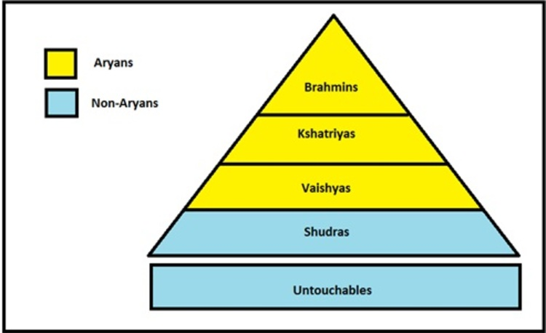[Click to enlarge]

The Untouchables
In addition to the varnas, there is a fifth class in Hinduism. It encompassed outcasts who, literally, did all the dirty work. They were referred to as "Untouchables" because they carried out the miserable tasks associated with disease and pollution. These tasks included cleaning up after funerals, dealing with sewage, and working with animal skin.
Brahmins were considered symbols of purity, and Untouchables symbols of pollution. Physical contact between the two groups was absolutely prohibited. Brahmins followed this rule so completely that they felt obliged to bathe if even the shadow of an Untouchable fell across them.

Struggling Against Tradition
The political and social force of the caste system has not disappeared completely. However, the Indian government has officially outlawed caste discrimination and made widespread reforms. Particularly through the efforts of Indian nationalists such as Mohandas Gandhi, the government has loosened rules that prevented contact between the castes.
Gandhi renamed the Untouchables Harijans, which means "the people of God." Adopted in 1949, the Indian Constitution provided a legal framework for the liberation of Untouchables and for the equality of all citizens.
In recent years, the Untouchables have become a politically active group. They have adopted for themselves the name Dalits, which means "those who have been broken."

