Name: __________________________
Buddhism and the Buddha
I. Listen to the story of Siddhartha to fill in the reading guide. Describe the following terms and ideas in your own words:
1. Siddhartha Gautama’s birth and early life:

2. Siddhartha Gautama’s chariot ride:

3. Ascetic:

4. The Middle Way:

5. The four Noble Truths:

A.
B.
C.
D.

6. The three sections of the Eightfold Path:

A. Wisdom:

B. Ethical Conduct:

C. Mental Discipline:

II. Put the Following quotes by Siddhartha into the category to which you think they belong.
#1: “All material (created) things in the world are impermanent.”
#2: “It is better to conquer yourself than to win a thousand battles. Then the victory is yours. It cannot be taken from you, not by angels or by demons, heaven or hell.”
#3: “We are what we think. All that we are arises with our thoughts. With our thoughts we make the world.”
#4:” Holding on to anger is like grasping a hot coal with the intent of throwing it at someone else; you are the one who gets burned.”
#5: “No one saves us but ourselves. No one can and no one may. We ourselves must walk the path.”
#6: “However many holy words you read, however many you speak, what good will they do you if you do not act on upon them?”
#7: “A problem cannot cause suffering. It is our thinking and attachment that cause suffering.”
Life is Suffering | Suffering is caused by desire | Wisdom: perceiving the true nature of ourselves and the world around us; the energy and commitment one needs to be fully engaged in Buddhist practice. | Ethical Conduct: take care in our speech, our actions, and our daily lives to do no harm to others and to cultivate wholesomeness in ourselves. | Mental Discipline: Through Right Effort, Right Mindfulness, and Right Concentration we develop the mental discipline to cut through delusion.
 |  |  | #6

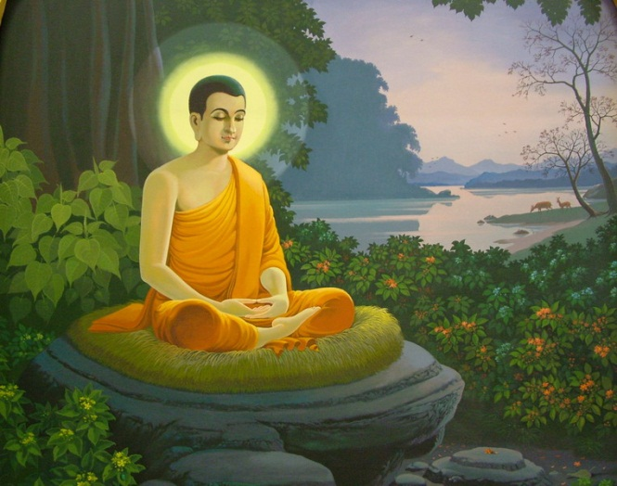
The Life of the Buddha

Siddhartha Gautama's Early Life
Siddhartha Gautama was born about 583 BCE, in or near what is now Nepal. His father, King Suddhodana, was leader of a large clan called the Shakya. His mother, Queen Maya, died shortly after his birth.
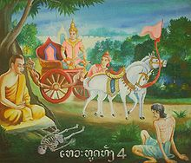
When Prince Siddhartha was a few days old, a holy man prophesied the Prince would be either a great military conqueror or a great spiritual teacher. King Suddhodana preferred the first outcome and prepared his son accordingly. He raised the boy in great luxury and shielded him from knowledge of religion and human suffering. The Prince reached the age of 29 with little experience of the world outside the walls of his opulent palaces.

The Four Passing Sights
One day, overcome with curiosity, Prince Siddhartha asked a charioteer to take him on a series of rides through the countryside. On these journeys he was shocked by the sight of an old man, then a sick man, and then a corpse. The stark realities of old age, disease, and death seized and sickened the Prince.
Finally, he saw a wandering ascetic. The chariot driver explained that the ascetic was one who had renounced the world and sought release from fear of death and suffering.
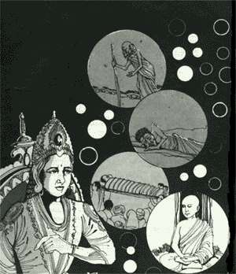
The Renunciation
For a time the Prince returned to palace life, but he took no pleasure in it. Even the news that his wife Yasodhara had given birth to a son did not please him. The child was called Rahula, which means "fetter."
One night he wandered the palace alone. The luxuries that had once pleased him now seemed grotesque. Musicians and dancing girls had fallen asleep and were sprawled about, snoring and sputtering. Prince Siddhartha reflected on the old age, disease, and death that would overtake them all and turn their bodies to dust.
He realized then that he could no longer be content living the life of a prince. That very night he left the palace, shaved his head, and changed his prince's clothes for a beggar's robe. Then he began his quest for enlightenment.

The Search
Siddhartha began by seeking out renowned teachers, who taught him about the many religious philosophies of his day as well as how to meditate. But after he had learned all they had to teach, his doubts and questions remained. So he and five disciples left to find enlightenment by themselves.
The six companions attempted to find release from suffering through physical discipline--enduring pain, holding their breath, fasting nearly to starvation. Yet Siddhartha was still unsatisfied. It occurred to him that in renouncing pleasure he had grasped pleasure's opposite--pain and self-mortification. Now Siddhartha considered a Middle Way between those two extremes.
He remembered an experience from his childhood, when his mind had settled into a state of deep peace. The path of liberation was through discipline of mind. He realized that instead of starvation, he needed nourishment to build up his strength for the effort. But when he accepted a bowl of rice milk from a young girl, his companions assumed he had given up the quest and abandoned him.

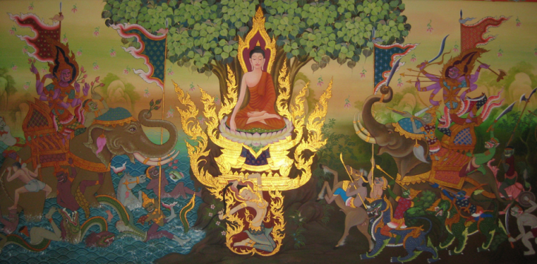
The Enlightenment of the Buddha
Siddhartha sat beneath a sacred fig tree (Ficus religiosa), known ever after as the Bodhi Tree, and settled into meditation.
The work of Siddhartha's mind came to be mythologized as a great battle with Mara, a demon whose name means ‘destruction’ and who represents the passions that snare and delude us. Mara brought vast armies of monsters to attack Siddhartha, who sat still and untouched. Mara's most beautiful daughter tried to seduce Siddhartha, but this effort also failed.
Finally, Mara claimed the seat of enlightenment rightfully belonged to him. Mara's spiritual accomplishments were greater than Siddhartha's, the demon said. Mara's monstrous soldiers cried out together, "I am his witness!" Mara challenged Siddhartha--who will speak for you?
Then Siddhartha reached out his right hand to touch the earth, and the earth itself roared, "I bear you witness!" Mara disappeared. And as the morning star rose in the sky, Siddhartha Gautama realized enlightenment and became a Buddha (“the Awakened One”).

The Teacher
At first, the Buddha was reluctant to teach, because what he had realized could not be communicated in words. Only through discipline and clarity of mind would delusions fall away and the Great Reality be directly experienced. Listeners without that direct experience would be stuck in conceptualizations and would surely misunderstand everything he said. But compassion persuaded him to make the attempt.
After his enlightenment, he went to the Deer Park in Isipatana, located in what is now the province of Uttar Pradesh, India. There he found the five companions who had abandoned him, and to them he preached his first sermon. This sermon centers on the Four Noble Truths. Instead of teaching doctrines about enlightenment, the Buddha chose to prescribe a path of practice through which people can realize enlightenment for themselves.
The Buddha, himself a member of the Warrior caste, challenged the caste system. He preached that people should be judged by their acts, not their position at birth. He preached that caste had no basis in reality and that low caste people were as spiritually pure as the highest Brahman: "Birth does not make one a priest or an outcaste. Behavior makes one either a priest or an outcaste." Disregarding one of the major taboos of the time, he allowed women to participate in the growing Buddhist community as equals, even ordaining nuns, and he taught that women were just as capable of achieving Enlightenment as men.
The Buddha focused his teaching on individuals and their immediate struggles to reach Enlightenment. He stated that speculation about the origin of the universe was a waste of time and a distraction. He felt that human belief in gods was based on our fear and uncertainty: "Gripped by fear, men go to the sacred mountains,
sacred groves, sacred trees and shrines".
The Buddha devoted himself to teaching, attracting hundreds of followers. Eventually he became reconciled with his father, King Suddhodana. His wife, the devoted Yasodhara, became a nun and disciple. Rahula, his son, became a novice monk at the age of 7 and spent the rest of his life with his father.

Last Words
The Buddha tirelessly traveled and taught until his death at age 80. His last words to his followers:
"Behold, O monks, this is my last advice to you. All created things in the world are impermanent. They will not last. Work hard to gain your own salvation."
The Buddha's first sermon after his Enlightenment centered on the Four Noble Truths, which are the foundation of Buddhism. The truths are:
- The Truth of Suffering
The First Noble Truth often is translated as "Life is suffering."
- The Truth of the Cause of Suffering
The Second Noble Truth teaches that the cause of suffering is craving or thirst (tanha). We continually search for something outside ourselves to make us happy. But no matter how successful we are, we never remain satisfied.
The Buddha taught that this thirst grows from ignorance of the self. We go through life grabbing one thing after another to get a sense of security about ourselves. We attach not only to physical things, but also to ideas and opinions about ourselves and the world around us. Then we grow frustrated when the world doesn't behave the way we think it should and our lives don't conform to our expectations.
- The Truth of the End of Suffering
The Buddha's teachings on the Four Noble Truths are sometimes compared to a physician diagnosing an illness and prescribing a treatment. The first truth tells us what the illness is, and the second truth tells us what causes the illness. The Third Noble Truth holds out hope for a cure.
The Buddha taught that through diligent practice, we can put an end to craving. Ending the hamster-wheel chase after satisfaction is enlightenment (bodhi, "awakened"). The enlightened being exists in a state called Nirvana.
- The Truth of the Path That Frees Us From Suffering
Here the Buddha as physician prescribes the treatment for our illness: The Eightfold Path. Unlike in many other religions, in Buddhism there is no particular benefit to merely believing in a doctrine. Instead, the emphasis is on living the doctrine and walking the path.

The Eightfold Path is the means by which enlightenment may be realized.
The Eightfold Path is:
- Right View
- Right Intention
- Right Speech
- Right Action
- Right Livelihood
- Right Effort
- Right Mindfulness
- Right Concentration
The Path is divided into three main sections: wisdom, ethical conduct, and mental discipline.
Wisdom: Right View and Right Intention are the wisdom path. Right View is not about believing in doctrine, but in perceiving the true nature of ourselves and the world around us. Right Intention refers to the energy and commitment one needs to be fully engaged in Buddhist practice.
Ethical Conduct: Right Speech, Right Action and Right Livelihood are the ethical conduct path. This calls us to take care in our speech, our actions, and our daily lives to do no harm to others and to cultivate wholesomeness in ourselves.
Mental Discipline: Through Right Effort, Right Mindfulness, and Right Concentration we develop the mental discipline to cut through delusion. Many schools of Buddhism encourage seekers to meditate to achieve clarity and focus of mind.

